Havant Rifle and Pistol Club

Sunday 31 July 2016

10 Metre Open Air Gun Meeting
Rifle and Pistol

SHOT IN CLASSES AS PER THE ELEY COMPETITION

60 SHOT COURSE OF FIRE

50% of the entry fee to be returned as prizes
Entry is by email, the organiser reserves the right to reclassify a shooter after shooting.
Entry fee £10.00 payable on the day at the time of collecting targets.
Cheques made payable to Havant Rifle & Pistol Club
The Club has disabled access and firing points

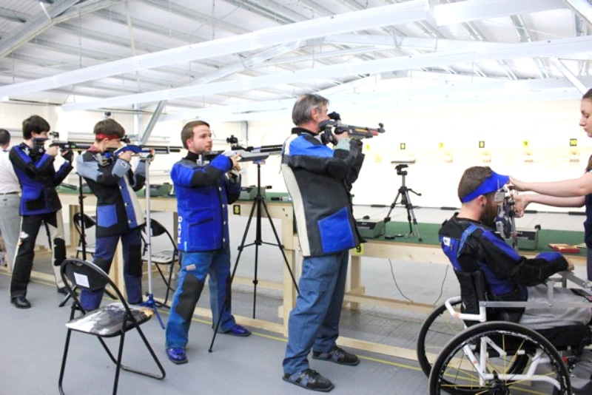
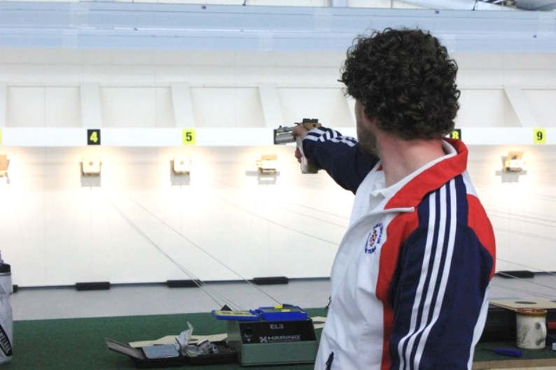

ENTRY FORM

NAME: ………………………………………………. CLUB: ………………………………

ADDRESS: ………………………………………………………………………………………………………

Email address: ……………………………………………….. TEL No: …………………………….
(For squadding details / results)

Air Rifle 10 metres Entry Fee £10.00
Classification based on last 10 scores at 10 Metres:

........ ........ ........ ........ ........ ........ ........ ........ ........ ........ = Average of................ Disabled Y/N

A Class 90 and over, B Class 84 and under 90, C Class 75 and under 84, D Class under 75

Air Pistol 10 metres Entry Fee £10.00
Classification based on last 10 scores at 10 Metres:

........ ........ ........ ........ ........ ........ ........ ........ ........ ........ = Average of................ Disabled Y/N
A Class 90 and over, B Class 87 and under 90, C Class 83 and under 87, D Class 79 and under 83
E Class under 79
Course of Fire
Shooting will start at the times below. Rifle or Pistol is to remain on the firing point until shooting is started by the Range Officer.

Rifle:-
1 hour 45 minutes, unlimited sighters on four sighting cards and 60 shots to count, one shot per diagram.
Pistol:-
1 hour 45 minutes, unlimited sighters on four sighting cards and 60 shots to count, five shots per card.
When Range Officer has ended shooting please move off the firing point to let the next squad in.

Competitors are requested to specify their preferred Start Time below by selecting a SQUAD, please indicate 1st, 2nd, 3rd choices
Squad A | Squad B | Squad C | Squad D
09:00 | 11:00 | 13:00 | 15:00

PLEASE RETURN ENTRY FORMS BY EMAIL OR POST TO:-

alanperry1946@gmail.com
[Alan Perry 15 Kendal Close Waterlooville Hampshire PO8 8ET]

Directions and further entry forms are on the Club web site
http://www.havant-rpc.co.uk/

CLUB MEMBERSHIP AVAILABLE

Data Protection Act 1984: The Competition Organiser is required to inform that the following will be stored on computer for the purposes of preparing entry forms and other internal purposes: Name, Address, Telephone and other Shooting connected information.

